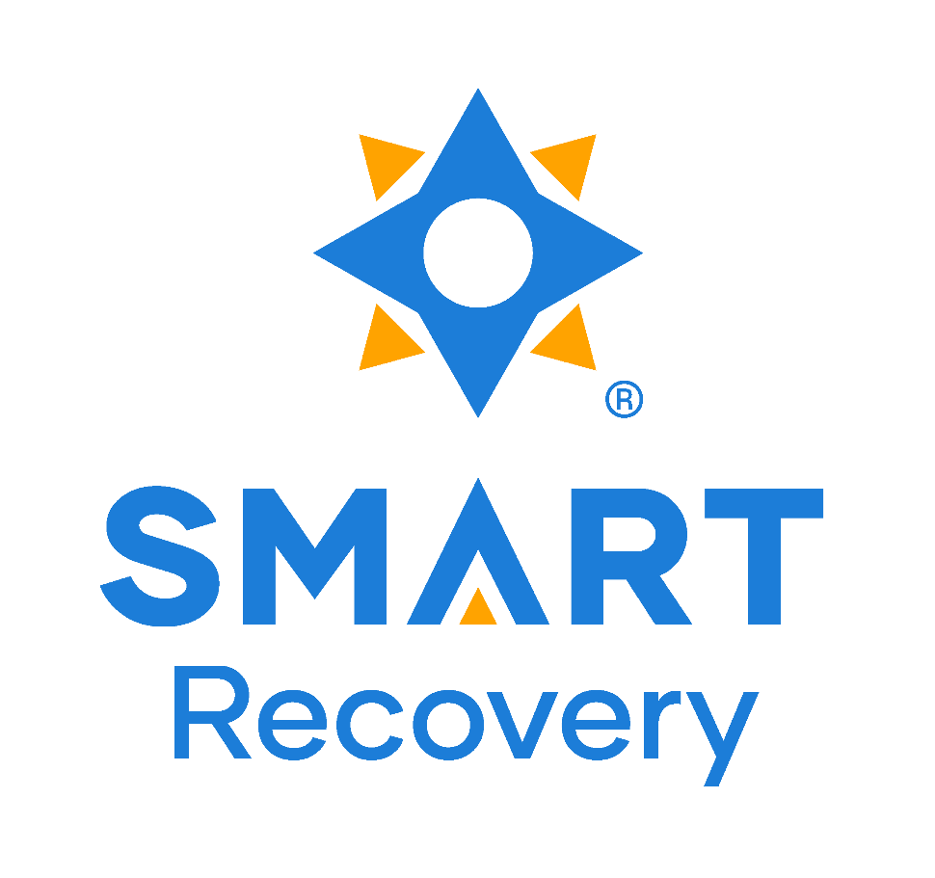

<insert QR code here>

SMART Recovery USA provides support to over 1,000 public meetings like ours nationally. You can help fund that support by donating through the “Support this Meeting” button in SMART*finder.* Thank you!